

Rossmoyne Senior High School

Semester One Examination, 2016

Question/Answer Booklet

MATHEMATICS

SOLUTIONS
SPECIALIST
UNIT 3

Section Two:

Calculator-assumed

Student Number: In figures

In words

Your name

Time allowed for this section
Reading time before commencing work: ten minutes
Working time for section: one hundred minutes

Materials required/recommended for this section
To be provided by the supervisor
This Question/Answer Booklet
Formula Sheet (retained from Section One)

To be provided by the candidate
Standard items: pens (blue/black preferred), pencils (including coloured), sharpener, correction fluid/tape, eraser, ruler, highlighters

Special items: drawing instruments, templates, notes on two unfolded sheets of A4 paper, and up to three calculators approved for use in the WACE examinations

Important note to candidates
No other items may be taken into the examination room. It is your responsibility to ensure that you do not have any unauthorised notes or other items of a non-personal nature in the examination room. If you have any unauthorised material with you, hand it to the supervisor before reading any further.

Structure of this paper

Section | Number of questions available | Number of questions to be answered | Working  time (minutes) | Marks available | Percentage of exam
Section One:  Calculator-free | 7 | 7 | 50 | 53 | 35
Section Two:  Calculator-assumed | 12 | 12 | 100 | 98 | 65
 |  |  | Total | 151 | 100

Instructions to candidates

- The rules for the conduct of examinations are detailed in the school handbook. Sitting this examination implies that you agree to abide by these rules.

- Write your answers in this Question/Answer Booklet.

- You must be careful to confine your response to the specific question asked and to follow any instructions that are specified to a particular question.

- Spare pages are included at the end of this booklet. They can be used for planning your responses and/or as additional space if required to continue an answer.
- Planning: If you use the spare pages for planning, indicate this clearly at the top of the page.
- Continuing an answer: If you need to use the space to continue an answer, indicate in the original answer space where the answer is continued, i.e. give the page number. Fill in the number of the question that you are continuing to answer at the top of the page.

- Show all your working clearly. Your working should be in sufficient detail to allow your answers to be checked readily and for marks to be awarded for reasoning. Incorrect answers given without supporting reasoning cannot be allocated any marks. For any question or part question worth more than two marks, valid working or justification is required to receive full marks. If you repeat any question, ensure that you cancel the answer you do not wish to have marked.

- It is recommended that you do not use pencil, except in diagrams.

- The Formula Sheet is not to be handed in with your Question/Answer Booklet.

Section Two: Calculator-assumed 65% (98 Marks)
This section has twelve (12) questions. Answer all questions. Write your answers in the spaces provided.

Working time for this section is 100 minutes.

Question 8 (5 marks)
Consider the function .

(a) Explain why it is necessary to restrict the natural domain of f in order that its inverse is also a function. (1 mark)
Solution
is not a one-to-one function for
Specific behaviours
explains function is not one-to-one over natural domain

(b) State a minimal restriction to the domain of f that includes , and then use this restriction to show that . (4 marks)
Solution
f has a turning point at (2, -4) and so minimal restriction is to include

Specific behaviours
states minimal restriction to domain that includes
completes square on RHS, adjusting LHS
chooses, with reason, +ve root
states inverse

Question 9 (5 marks)
(a) Let z be a non-zero complex number located in the complex plane. Describe the linear transformation(s) required to transform z to each of the following locations:

(i) 2z. (1 mark)
Solution
Dilation of scale factor 2 about the origin.
Specific behaviours
states dilation with scale factor and centre

(ii) . (1 mark)
Solution
Rotation of 270° anticlockwise about origin.
Specific behaviours
states rotation with angle and centre

(b) Consider the complex number z shown in the Argand diagram below. Add to the diagram the location of u, v and w where , and . (3 marks)

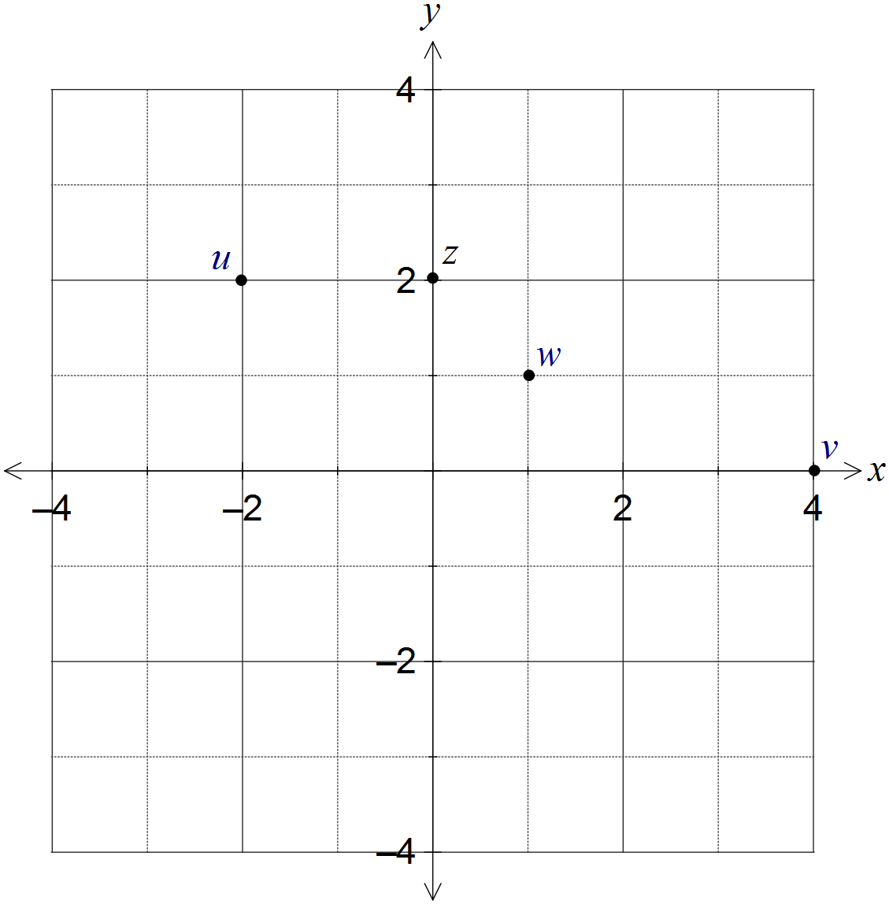
Solution
See diagram
Specific behaviours
places u correctly
places v correctly
places w correctly

Question 10 (8 marks)
Two functions are given by and .

(a) Determine and state the domain and range of this composite function. (3 marks)
Solution
Specific behaviours
writes simplified composite function
states domain
states range

(b) Show that the composite function is defined for . (3 marks)
Solution
Specific behaviours
substitutes g into f
simplifies root of square as absolute value
shows piecewise definition for all real x

(c) Sketch the graph of on the axes below. (2 marks)

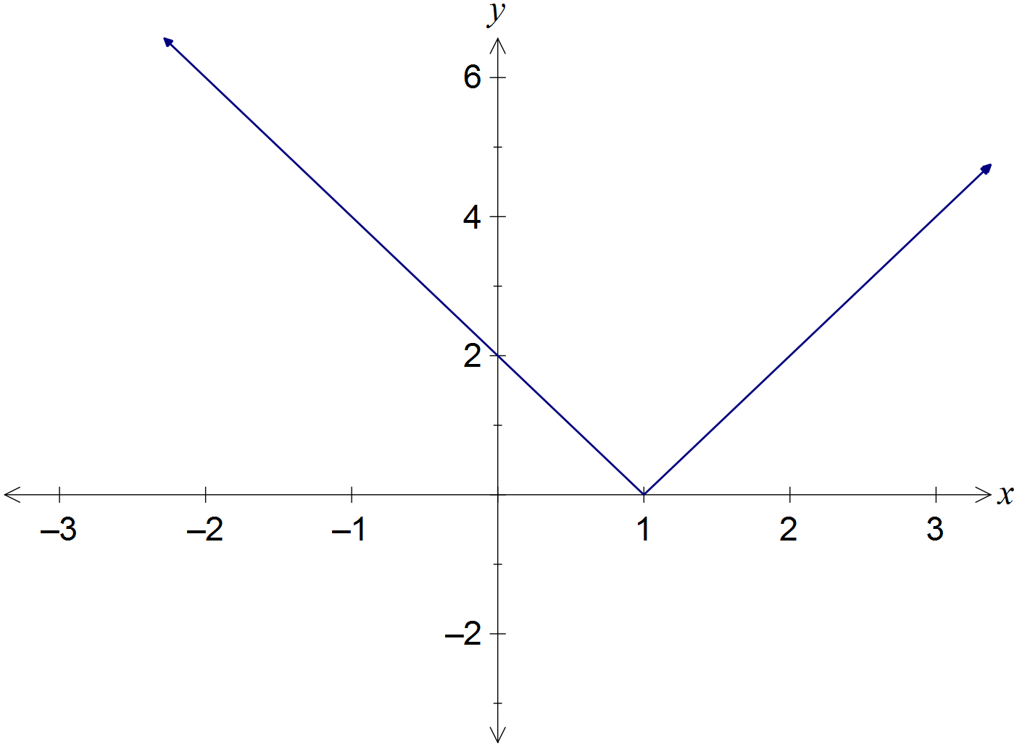
Solution
See diagram
Specific behaviours
all axes intercepts
shows two parts of composite function

Question 11 (12 marks)
(a) The graph of is shown below.

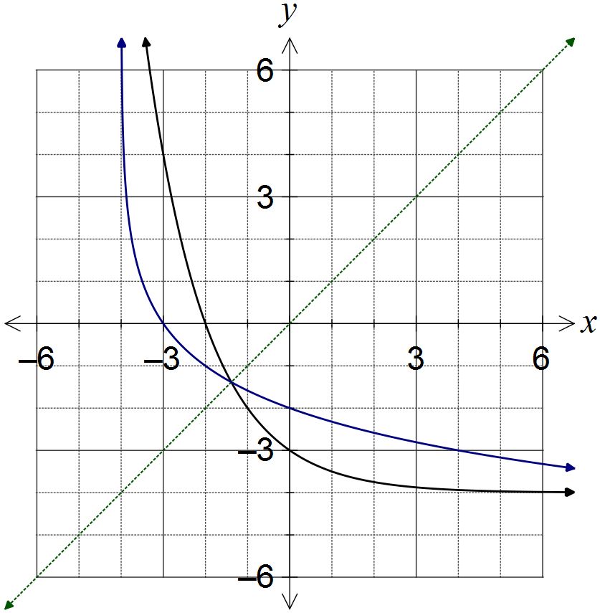
Solution
(ii) See diagram
Specific behaviours
both axes intercepts shown correctly
curve approaches vertical asymptote
smooth curve with as mirror line

(i) What feature of the graph suggests that the inverse of f is a function? (1 mark)
Solution
The part of the graph shown is clearly one-to-one using the horizontal line test.
Specific behaviours
describes function as one-to-one using graph feature

(ii) On the same axes, sketch the graph of the inverse of f, . (3 marks)

(b) The graph of is shown below.
On the same axes, sketch the graph of . (3 marks)

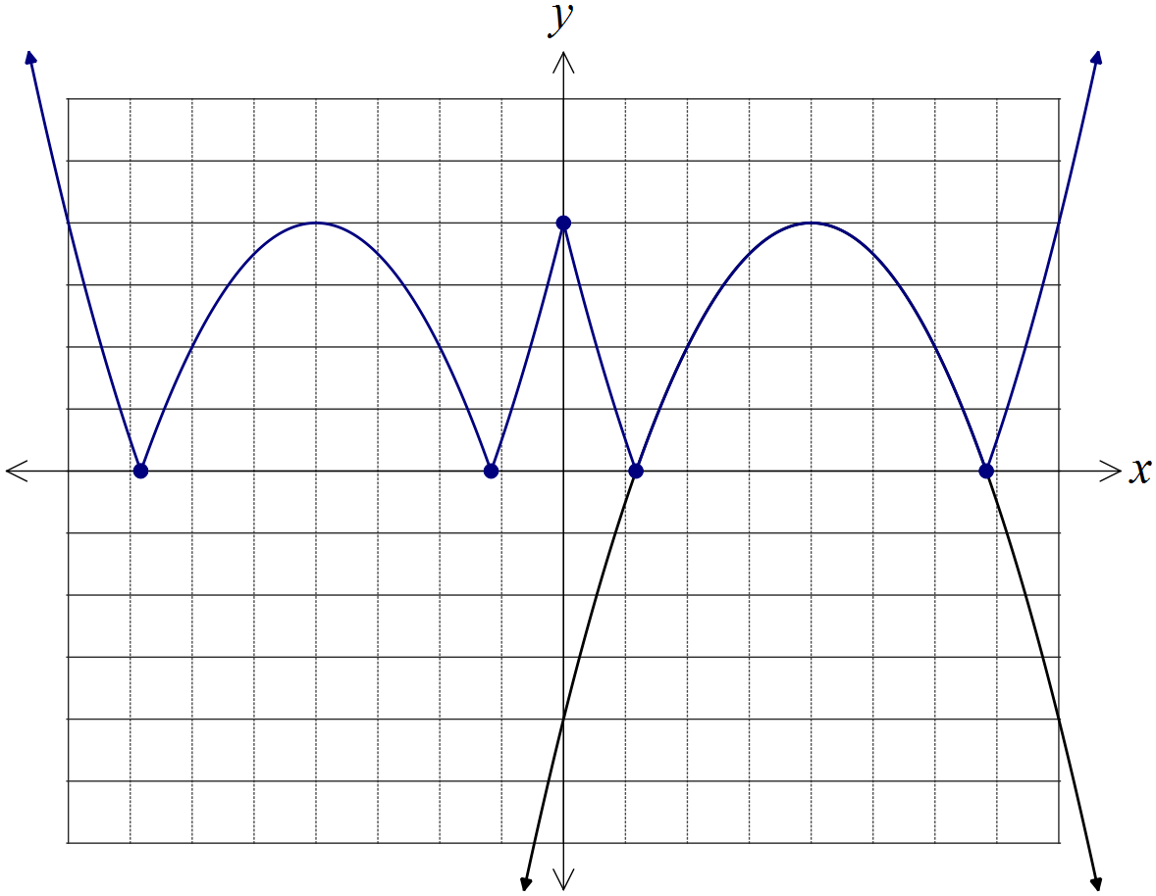
Solution
See diagram
Specific behaviours
reflects , in vertical axis to get
reflects in horizontal axis
all five indicated points in correct position

(c) The graph of is shown below. As . On the same axes, sketch the graph of , clearly indicating all vertical and horizontal asymptotes.
(5 marks)

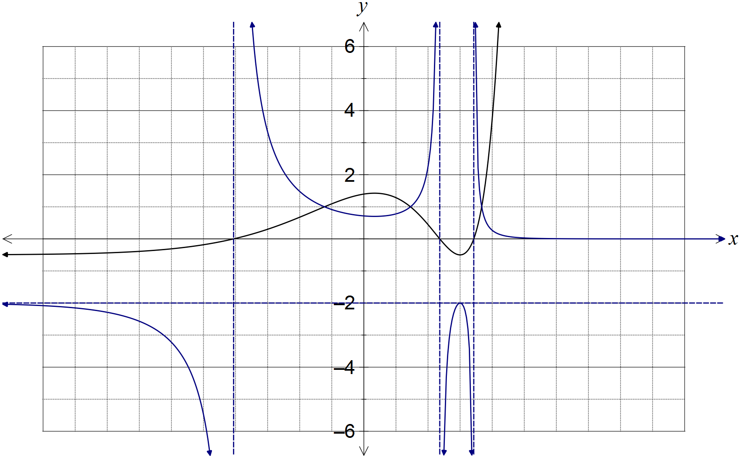

Solution
See diagram
Specific behaviours
correctly shows two parts of curve approaching horizontal asymptotes
correctly shows parts of curve approaching vertical asymptotes
correctly shows h and its reciprocal intersect three times when
uses y-axis scale to locate min and max correctly
smooth curves used throughout

Question 12 (8 marks)
(a) Determine all roots of the equation , expressing them in exact polar form where and . (5 marks)

Solution
Specific behaviours
expresses equation in polar form
expresses first root with correct modulus
expresses first root with correct argument
determines argument between roots
lists remaining five roots

(b) Show all solutions of the equation on the Argand diagram below. (3 marks)

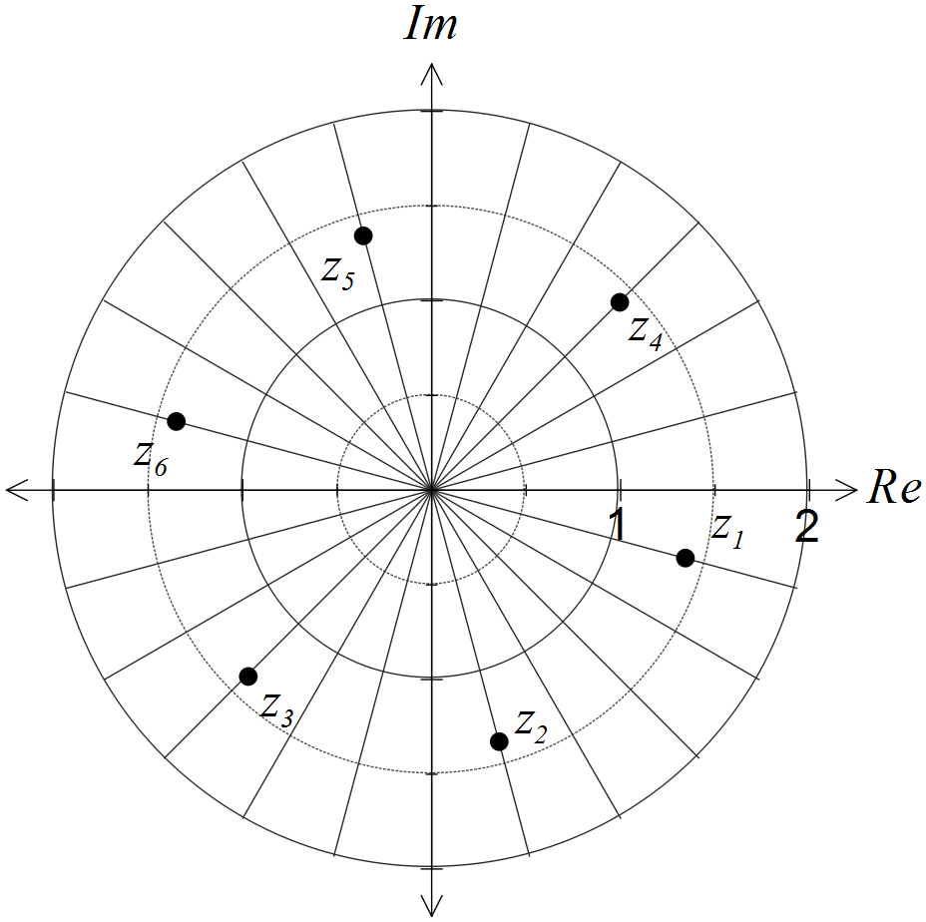
Solution
See diagram - six equally spaced points on circle
Specific behaviours
locates roots with
locates first root with correct argument
correctly spaces other five roots

Question 13 (7 marks)
Two small bodies, A and B, simultaneously leave their initial positions of and , and move with constant velocities of and respectively.

(a) Determine whether the paths of the bodies cross or if the bodies meet. (4 marks)
Solution
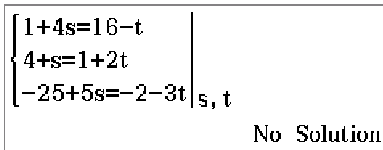

Paths of bodies do not cross, so bodies do not meet.
Specific behaviours
describe paths as vector equations
equate coefficients
states equations inconsistent/have no solutions
interprets that paths do not cross

(b) At the same time, a third small body, C, leaves its initial position, passes through the origin and crosses the path of body A. If C moves with a steady velocity of , determine the value of the constant a. (3 marks)
Solution
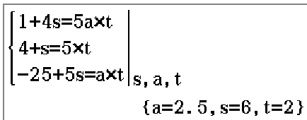
Specific behaviours
describe path of C as vector equation
equate coefficients
states value of a is 2.5

Question 14 (9 marks)
The function f is defined by.

(a) Determine the natural domain and range of . (4 marks)

Solution
Specific behaviours
factorises and simplifies f
states domain
states range using asymptote
includes 'hole' at (1, -2) in range

(b) Show that the function has no stationary points. (2 marks)

Solution
Specific behaviours
states
shows cannot be zero

(c) Sketch the graph of on the axes below. (3 marks)

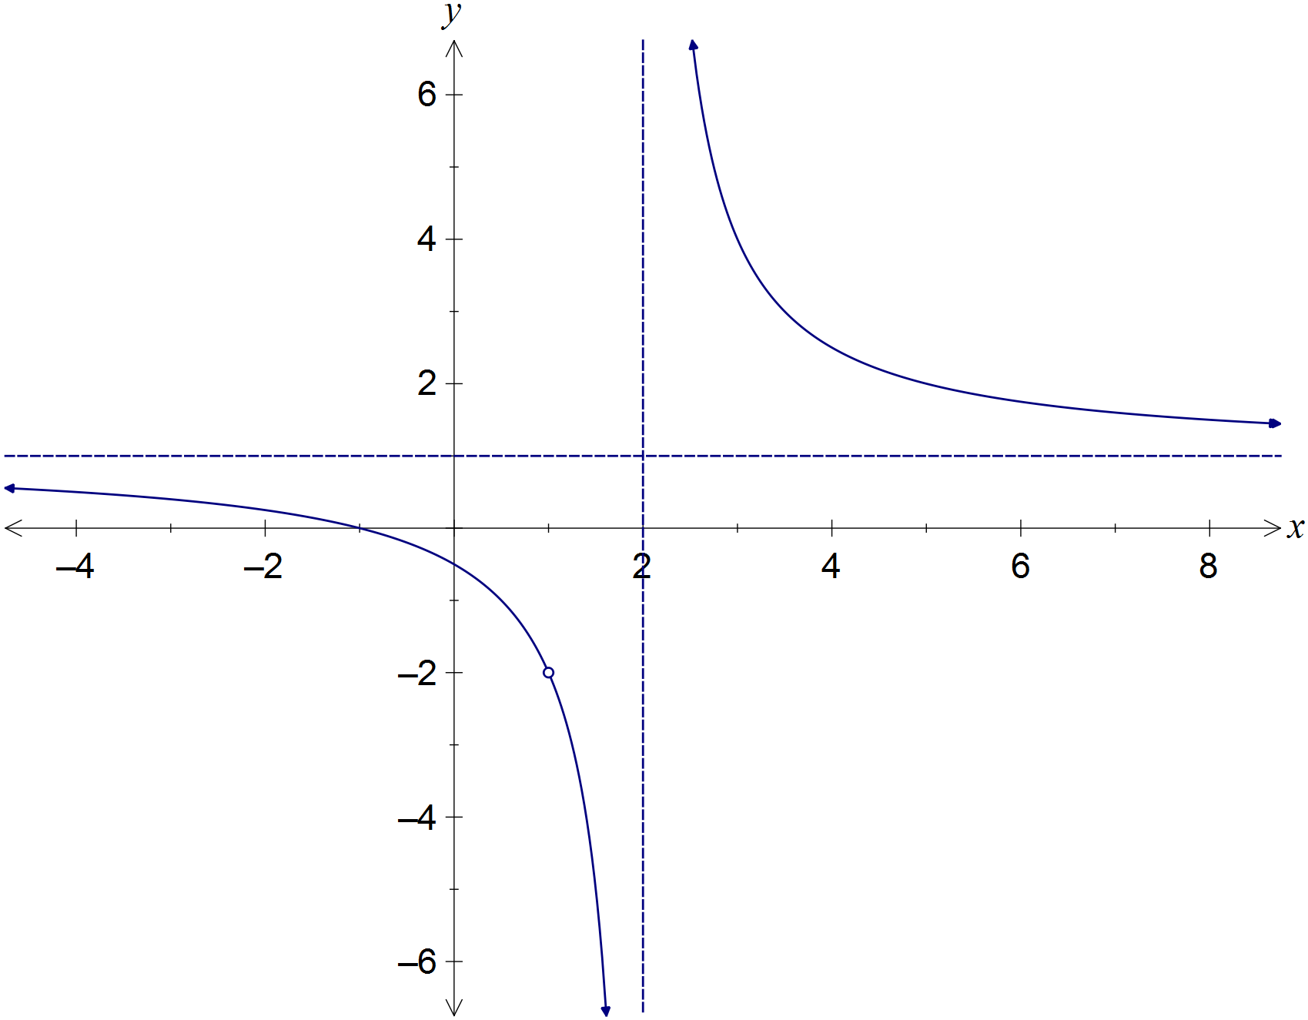

Solution
See diagram
Specific behaviours
axes intercepts
smooth curves approach asymptotes correctly
indicates undefined point

Question 15 (8 marks)
Given the two complex numbers and , determine the following in terms of the non-zero constants r, s, and :

(a) . (1 mark)
Solution
Specific behaviours
determines argument

(b) . (2 marks)
Solution
Specific behaviours
simplifies into form
states modulus

(c) . (2 marks)
Solution
Specific behaviours
simplifies into form
determines modulus

(d) . (3 marks)
Solution
Specific behaviours
writes and in cis form
simplifies into form
determines argument

Question 16 (7 marks)
Consider the three vectors , and .

(a) Prove that the three vectors do not lie in the same plane. (4 marks)

Solution
If vectors lie in the same plane, then a vector perpendicular to a and b will also be perpendicular to c.

Vector perpendicular to a and b is d:

Consider scalar product of c and d:

Since this is not zero, then c and d are not perpendicular, and so we conclude that the three vectors cannot lie in the same plane.
Specific behaviours
chooses cross product to find a perpendicular
calculates perpendicular correctly
chooses scalar product to show perpendicular not perpendicular to other vector
shows scalar product is not 0

(b) Determine the value(s) of the constant a if the vector lies in the same plane as vectors and . (3 marks)

Solution
Specific behaviours
calculates scalar product
solves scalar product equal to zero
determines all values of a

Question 17 (9 marks)
Let the complex number .

(a) Show that . (2 marks)
Solution
Specific behaviours
uses De Moivre's theorem to obtain
uses trig identity to obtain result

(b) Show that . (2 marks)
Solution
Specific behaviours
uses De Moivre's theorem to obtain triple angles
simplifies result

(c) Determine in terms of and .
(3 marks)
Solution
Specific behaviours
expands
expands
simplifies imaginary part

(d) Express in terms of and . (2 marks)
Solution
Using results from (b) and (c):
Specific behaviours
equates and eliminates from results in (b) and (c)
simplifies and rearranges for required result

Question 18 (13 marks)

The velocity vector of a particle at time t seconds is , for . When , the particle has position vector .

(a) Calculate the exact speed of the particle when . (2 marks)
Solution
Specific behaviours
determines the velocity vector
calculates the exact speed

(b) Determine the acceleration vector of the particle and comment on its direction. (2 marks)
Solution
Acceleration has no i component, so always acts parallel to y-axes.
Specific behaviours
differentiates velocity vector
states always acts parallel to y-axis, or vertically

(c) Determine the position vector of the particle for . (2 marks)
Solution
Specific behaviours
integrates velocity vector
evaluates constants and includes in position vector

(d) Derive the Cartesian equation of the path of the particle in the form . (2 marks)
Solution
Specific behaviours
expresses t in terms of x and y
eliminates parameter t and re-arranges for y

(e) On the axes below, sketch the path taken by the particle for , clearly indicating the position of the particle at the start and end of this interval. (3 marks)

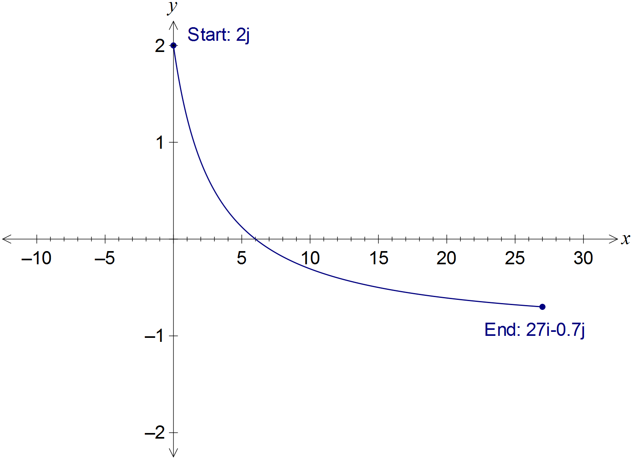
Solution
See graph
Specific behaviours
correct end points marked
x-intercept at (6, 0)
smooth curve

(f) Determine the length of the path travelled by the particle between and .
(2 marks)
Solution
Specific behaviours
writes correct integral
evaluates integral

Question 19 (7 marks)
(a) Shade the region satisfying the complex inequality on the Argand diagram below. (3 marks)

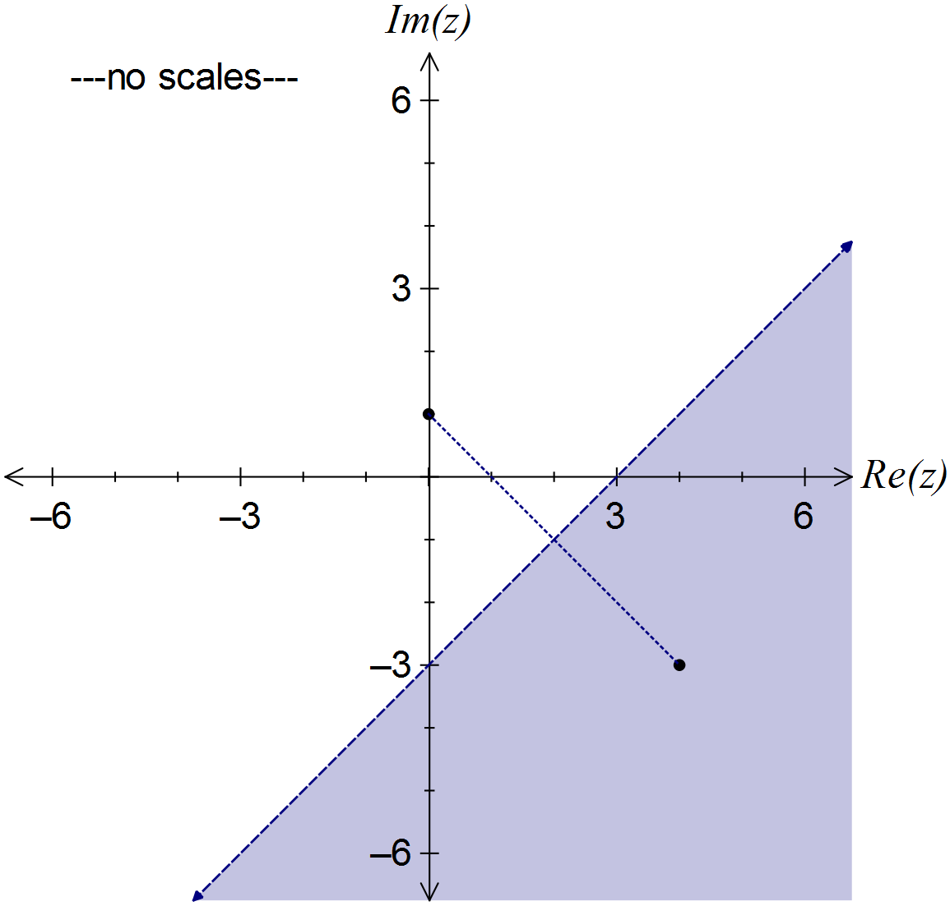
Solution
See diagram
Specific behaviours
adds scale and locates two points
draws perpendicular bisector of points using dotted line
shades correct region

(b) Consider the two complex numbers given by and . Sketch each of the following sets of points in the complex plane.

(i) . (2 marks)

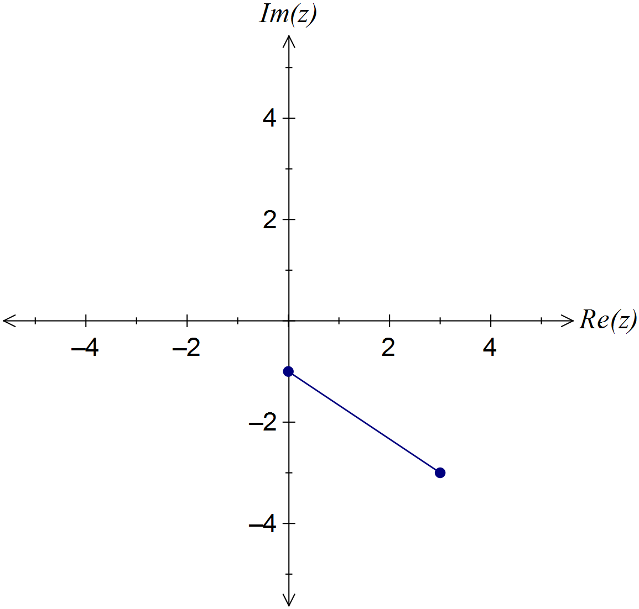
Solution
Distance of z from u plus distance of z from v equals distance of u from v
Specific behaviours
plots end points
joins end points with straight line

(ii) . (2 marks)

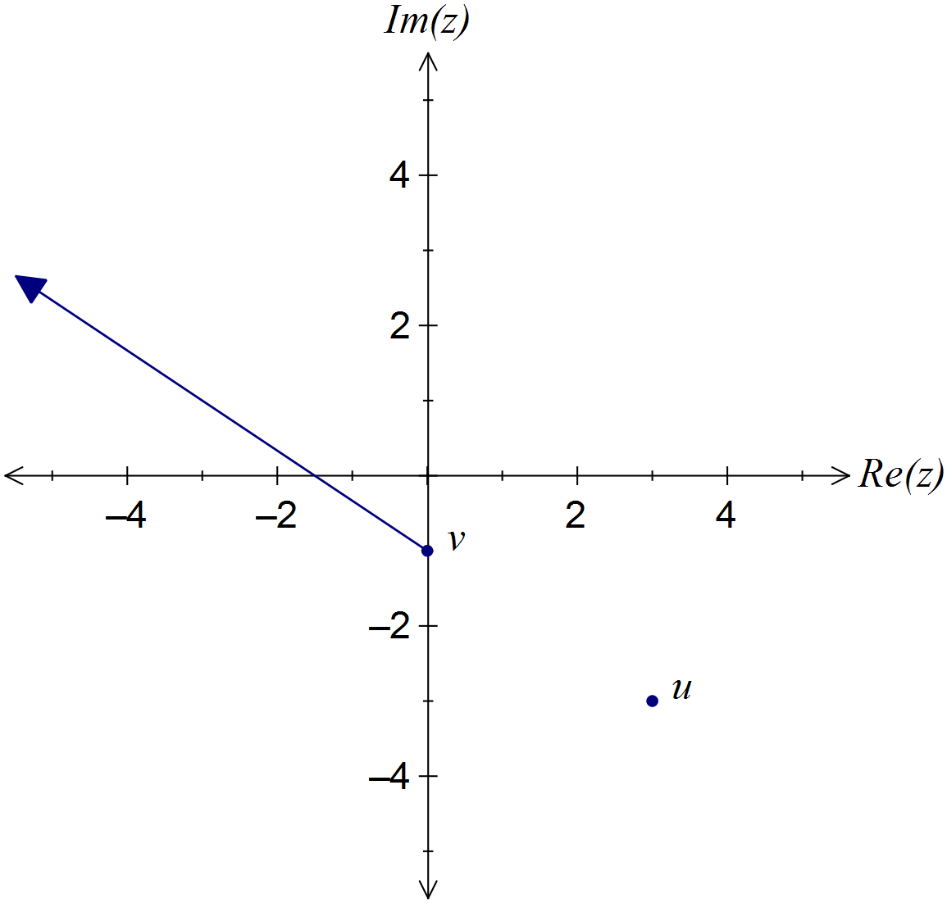
Solution
Distance of z from v plus distance of u from v equals distance of z from u
Specific behaviours
constructs straight line using points
indicates solution extends from v

Additional working space

Question number: _________

Additional working space

Question number: _________

Additional working space

Question number: _________

Additional working space

Question number: _________

© 2016 WA Exam Papers. Rossmoyne Senior High School has a non-exclusive licence to copy and communicate this paper for non-commercial, educational use within the school. No other copying, communication or use is permitted without the express written permission of WA Exam Papers.

